RESUME

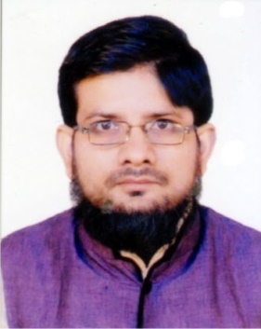
MR. MOHAMMAD AFZAL
Mobile: 08700892822, 9718939235
E-mail: mohdafzal88@gmail.com
Correspondence Address:
D-46, Ist Floor, Shaheen Bagh, Abul Fazal
Enclave Part-II Jamia Nagar,
New Delhi -110025

Objective:
To hold position of responsibility in a professionally managed organization & to be a part of a Dynamic and Progressive Organization where I can enhance my capability and capacity. To this end, I will try my best to live the expectations of the Organization.
Educational Qualification:
- M.A. (H) Urdu from Jamia Millia Islamia, New Delhi 2018 (60%).
- B.A. (H) Urdu from Jamia Millia Islamia, New Delhi.2016 (61%).
- Fadhil (equivalent 10+2) from Jamia Riyazul Uloom, Delhi.2009 (85%).
- Alim (equivalent 10th) from Jamia Islamia Sanabil, New Delhi.2007 (88%).
- Hifz from Mahad Uthman Bin Affan New Delhi. 2001 (92%).
Professional Qualification:
- One Year Diploma in Urdu Language from NCPUL (Ministry of HRD, Govt. of India), New Delhi.
- One Year Diploma in Computer Applications and Multilingual DTP from NCPUL & DOECC (Ministry of HRD, Govt. of India), New Delhi.
Computer Skills:
- MS Office 2007, InPage2009, Internet, e-mail & chat etc.
- Typing in English, Urdu & Arabic
Experience:
- Presently, I am working with the ISLAMI SAHITYA TRUST New Delhi as a Proofreader &Translator for the books published under the said organization.
- Also working with Sada-i-Bharat, a weekly news sharing portal Urdu, as a News-Editor cum Translator Hindi to Urdu & vice versa.
- Also worked with ISLAMIC BOOK SERVICE New Delhi from Feb. 2013 to Nov. 2014
- Also worked with FARID BOOK DEPOT NEW Delhi as a Proofreader & translator from Apr. 2009 to Jan. 2013
Hobbies:
- Reading newspapers & magazines.
- Writing for newspapers & magazines.
Languages known:
English, Urdu, Hindi & Arabic.
Personal details:
Father’s Name: (Late) Maqbool Ahmad
Date of Birth: 25 December, 1988
Place of Birth: Balrampur
Marital Status: Married
Nationality: Indian
Category: OBC
Permanent address:
Vill. Bijwa Kalan, Post: Trilokpur, Pachperwa, Distt. Balrampur - 271206 (UP)

Declaration:
Hereby, I declare that all the information furnished above is true to the best of my knowledge.

Dated: 04/08/2020
Place: New Delhi
(Mohammad Afzal)

